N/O | Item | Visual | Cost | Qty | Link | Comment
Enclosure and Mechanism
1 | 608zz Miniature Double Protection Metal Ball Bearings for Skateboarding Roller Inline Skates 8mm x 22mm x 7mm | 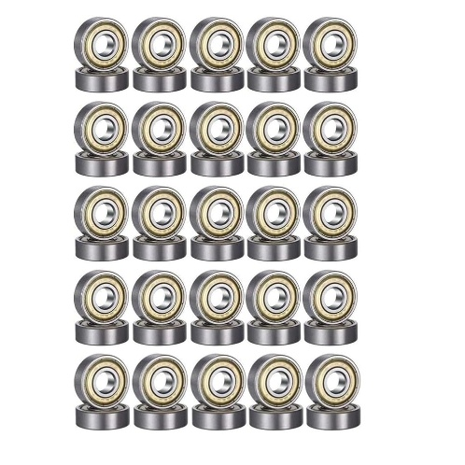 | €10.99 | 1 | Amazon | /
2 | M3 Set of Screws Bolts and Nuts and Washers Kit, Bolts Round Head Screws, Cross Head Cylindrical Screw, Machine Screw (Silver 870 Pieces M3) | Wv 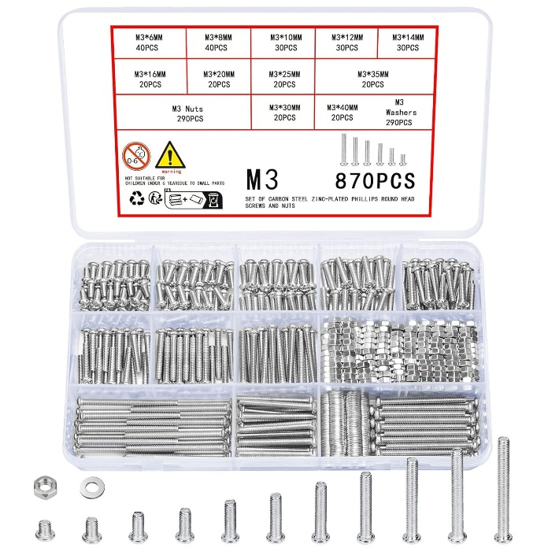 | €14.98 | 1 | Amazon | /
Electronics
3 | Microcontroller ESP32-S3 DevKitC-1 | 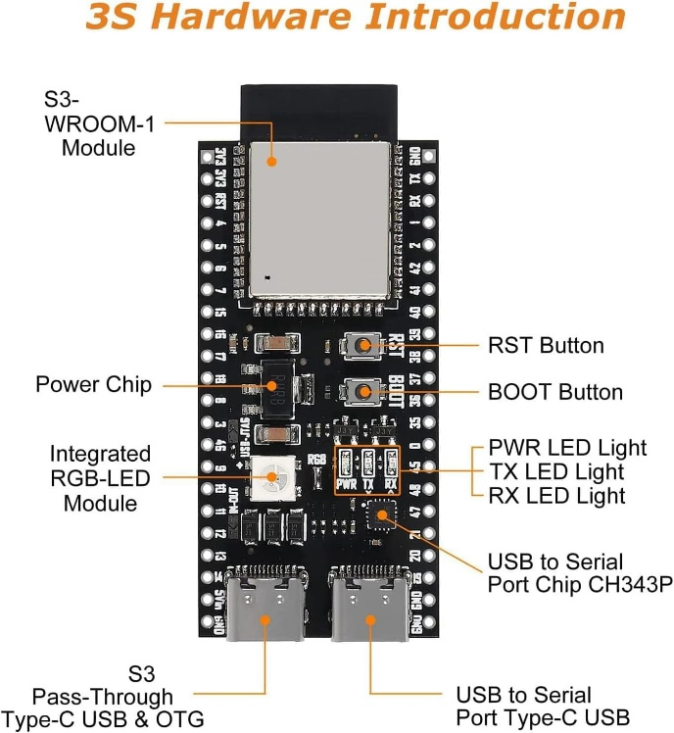 | €22.99 | 1 | Amazon | Used this because available in the lab from Agustin’s project,  Couldn’t use original Adafruit board because it works only with 5V motors also I think it was too sophisticated as even a basic microcontroller would work for this application.
4 | Motor Driver  DRV8871 DC Motor Driver Board Bob Drive Module 3.6A PWM Control Port Driver | 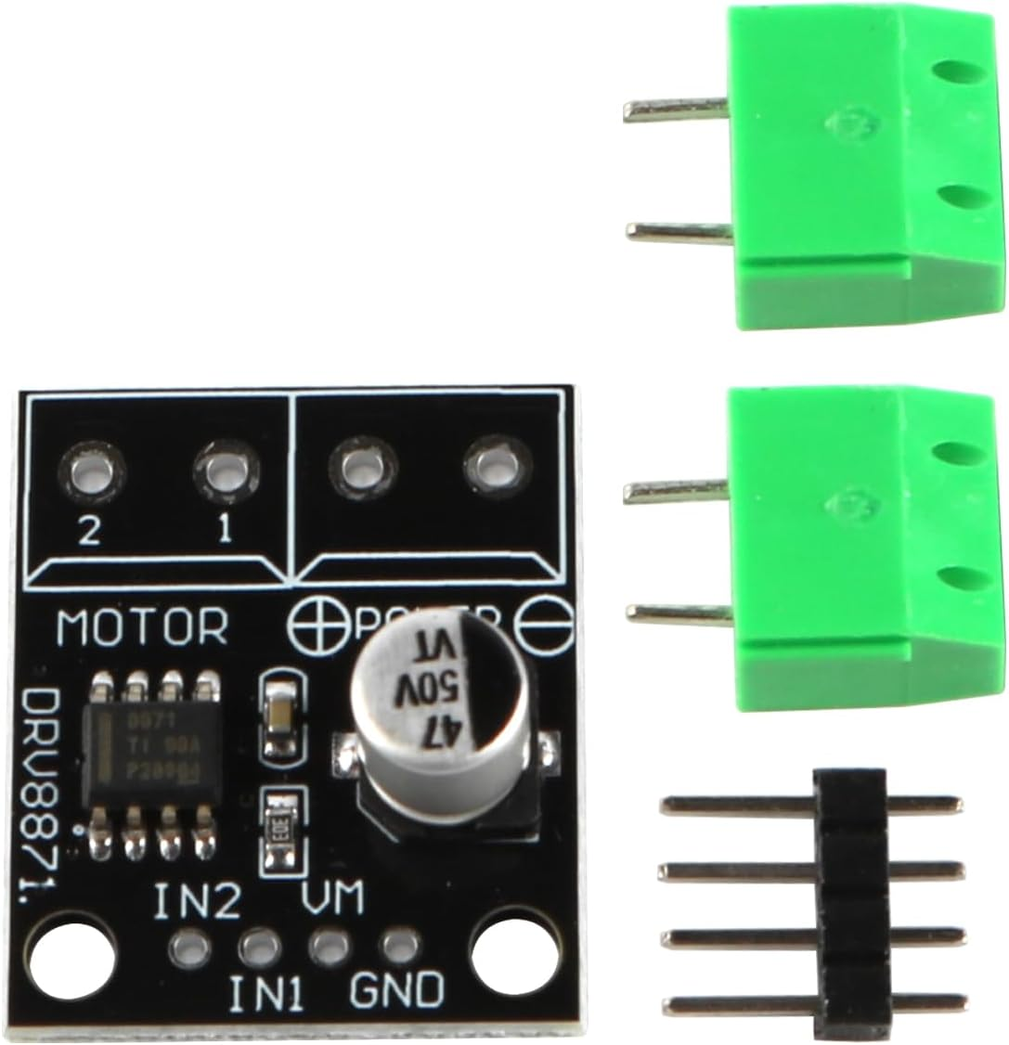 | €9.99 | 2 | Amazon | MOSFET-based H-bridge with lower power loss (565 mΩ RDS (on)), higher current handling (up to 3.6A peak), wider voltage range (6.5-45V), and built-in protections. This simplifies the design and improve reliability for prolonged operation (thermal shutdown prevents overheating during extended use).
5 | Input Device  20PCS  10K 3 Terminal Rotary Potentiometer for 10K Linear Potentiometer with Caps and Washer | 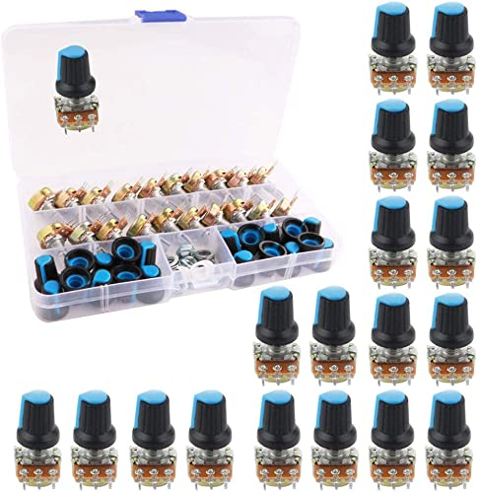 | €8.99 | 1 | Amazon | /
6.1 | DC Motor  CHANCS Worm Oriented Drive Motor 370WG 12V DC 375RPM for Range Hood Nesting Machine Intelligent Equipment | 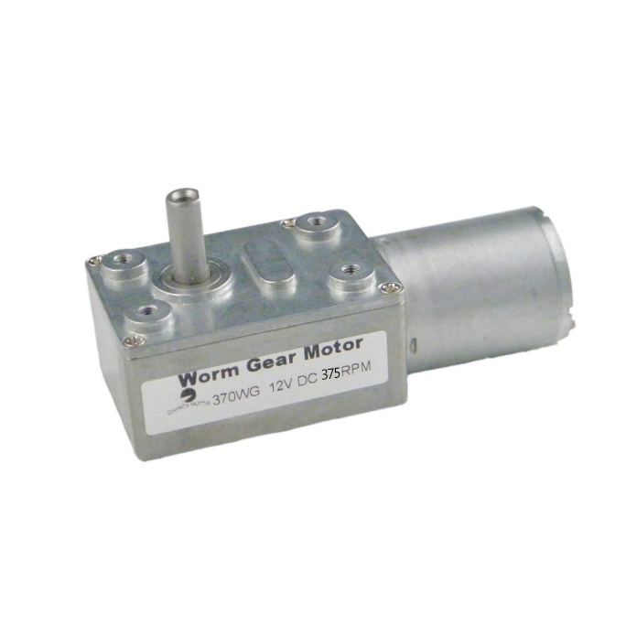 | €18.99 | 2 | Amazon | Preferred choice for cost effectiveness, worried about the torque power if the trays is full loaded with 250ml culture flask
7 | Power Connector  GTIWUNG 10 x DC Connector, DC Power Connectors, Barrel Power Jack Adapter 12 V Package includes: 5 Pairs DC 12V Connectors (Male + Female) 5 x Inline Rocker Switch | 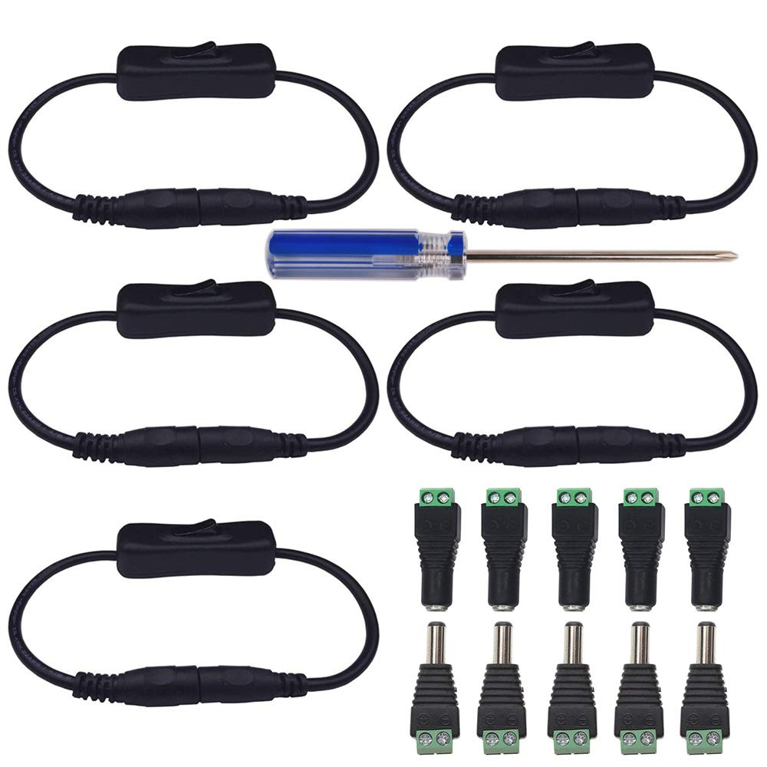 | €7.99 | 1 | Amazon | Will be useful for other projects as well
 | 12V Power Cable  Zolt 36W 12V 3A Universal Power Supply, 12V 1A 2A 3A AC DC Adapter Transformer with 9 DC Plugs for Electronics, 3000 mA Max. | 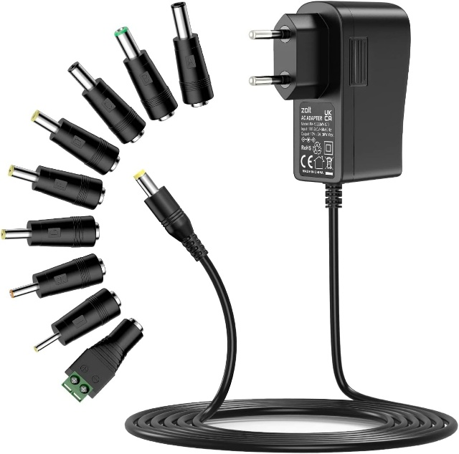 | €12.90 | 2 | Amazon | Will be useful for other projects as well
 | AZ-Delivery 3 x LM2596S LM2596 Step-Down DC-DC Buck Converter Module for 4-40V to 3.3-24V with 3-Digit Digital Display | 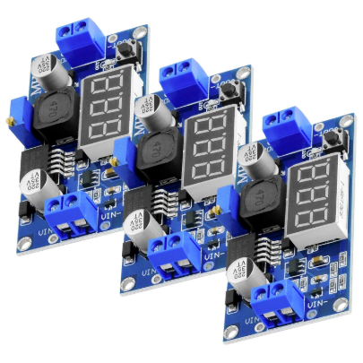 | €11.19 | 1 | Amazon | Required to safely power the entire circuit from a single 12V external adapter (via the DC jack)
 |  | Total cost) | 81.22 EUR

